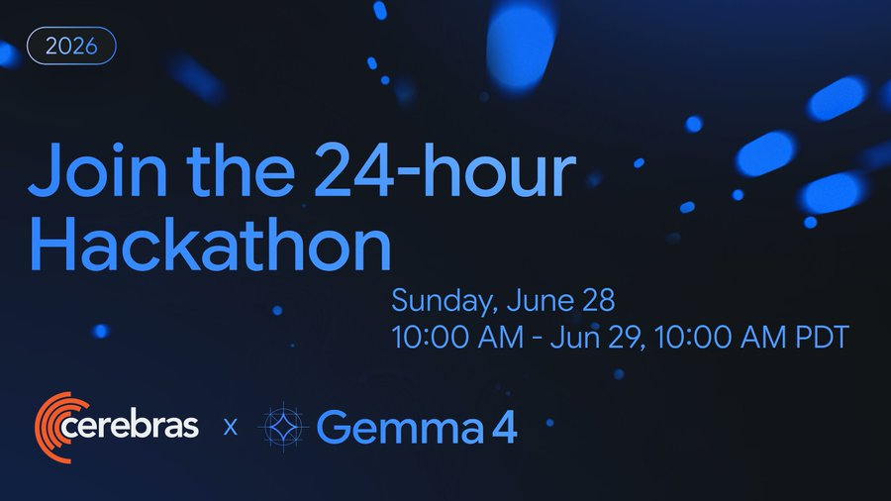

Cerebras is excited to present the Cerebras and Google DeepMind Gemma 4 24-Hour Hackathon! We’ve teamed up with Google DeepMind — leading AI research lab and the team behind Gemma. Whether you’re building agents, refactoring legacy code, or exploring new codebases, you can now work at the speed of thought using the latest open models like Gemma 4 — powered by Cerebras’ ultra-fast inference.

💰 PRIZES
Track 1: Multiverse Agents - Best Multi-Agent + Multimodal Use Case ($2K)
Track 2: People’s choice - Most Impressions on Social Media ($2K)
Track 3: Enterprise Impact - Best Enterprise Use Case ($1K)
📍Location: ​Cerebras Discord Server #gemma-4-hackathon
⏰ Timeline: (24 hours) Sunday, June 28 10:00AM PT - Monday, June 29 10:00 AM PT
- We will kick off with a 30 min intro + Q&A with the Gemma 4 Research team. All levels welcome!

📤 Submission Instructions
Share your demo by posting your demo recorded video and project description in the Discord channel(s) corresponding to the track(s) you would like to be considered for (these channels will become public after the start of the hackathon):
- Track 1: #g4hackathon-multiverse-agents
- Track 2: #g4hackathon-people-choice
  - Also post your demo video on X (Twitter) and tag @Cerebras and @googlegemma.
- Track 3: #g4hackathon-enterprise-impact
You may submit to multiple tracks. Please create a separate Discord post for each submission in the Discord channel track. You may update or resubmit your project as many times as you'd like before the submission deadline, Monday, June 29th at 10 AM Pacific Standard Time.

📹 Demo Video Requirements
- Maximum length: 60 seconds
- Show Cerebras speed: Clearly demonstrate how fast inference improves the user experience
- Recommended: Include a side-by-side comparison with a GPU-based provider to highlight latency improvements
- Focus on your project: Showcase the key features, workflow, and impact
- Protect your privacy: If recording your desktop, ensure no personal or sensitive information is visible (e.g. notifications, browser tabs, API keys, emails, or credentials)

🧑‍⚖️Judging Criteria:
Track 1: Multiverse Agents - Best Multi-Agent + Multimodal Use Case (2K)
- Agent Collaboration: Effective coordination between multiple AI agents
- Multimodal Intelligence: Meaningful use of Gemma 4 31B with text, images, and video
- Speed in Action: Demonstrates the impact of Cerebras' ultra-fast inference
- Innovation: Creative, outside-the-box applications that leverage Gemma 4 31B, including physical AI, robotics, embodied agents, or other real-world systems (Examples include Reachy robots, 3D printing workflows, smart manufacturing, autonomous labs, IoT, and other physical-world integrations.)
Track 2: People’s choice - Most Impressions on Social Media (2K)
- Organic Reach: Highest number of organic impressions on Twitter/X (no paid promotion/amplification)
- Community Engagement: Strong engagement through likes, comments, reposts, and discussions
- Content Quality: Clear, compelling, and creative showcase of the project
- Authenticity: Genuine community excitement around the project and Cerebras + Gemma 4 31B
Track 3: Enterprise Impact - Best Enterprise Use Case (1K)
- Business Impact: Solves a meaningful enterprise challenge such as enterprise search, multimodal RAG, incident response, cybersecurity, customer support, or knowledge management
- Production Readiness: Scalable, secure, and deployable in real-world environments
- Technical Excellence: Thoughtful architecture and high-quality implementation
- AI Differentiation: Demonstrates how Cerebras speed and Gemma 4 31B's multimodal capabilities create a better enterprise experience

❓Commonly Asked Q&As:

Do participants get higher rate limits/credits than the public free tier (30 RPM / 1M tokens-day)

Yes. During the hackathon, each participant will receive elevated API capacity of 100 RPM and 100K TPM (tokens per minute), subject to overall platform demand.

How and when do we get keys / elevated access before kickoff?
To receive elevated API capacity, please complete the following steps:
- Sign up at Cerebras Cloud and locate your Organization ID (Org ID).
- Submit your Org ID through the capacity increase request form by Saturday, June 27, 7:00 PM PT.

Due to the large number of participants and capacity planning requirements, we are unable to accommodate requests submitted after the deadline. Participants who have filled out the capacity increase request form will receive private preview access beginning Sunday, June 28 at 10:30 AM PT.

Access will remain available through Monday, June 29 at 10:00 AM PT, covering the duration of the hackathon.

Are limits per-person or shared per team/org?
At launch of the hackathon, elevated API capacity will be allocated per participant.

Numbers of team members?
As many as you want but we recommend teams of 2.

Will Cerebra engineers be live for debugging during the event, and in which channel/hours?
Yes. The Cerebras team will be available to provide live technical support via the Hackathon Discord during the following hours (Pacific Time):

- Sunday, June 28: 10:30 AM – 12:30 PM PT
- Monday, June 29: 9:00 AM - 10:00 AM PT

Outside of these hours, the Discord channels will be monitored intermittently. While we will do our best to respond to questions related to submissions, use cases, and general support, technical troubleshooting will be limited during overnight PDT hours. We encourage participants to begin testing and troubleshooting as early as possible during the hackathon to help ensure that any technical issues can be addressed while the engineering team is available.

Must projects be built during the 24h, or is prepared scaffolding allowed?
Pre-existing scaffolding, boilerplate code, and development frameworks are permitted. However, the core project and its functionality should be developed during the hackathon and must leverage Gemma 4 running on Cerebras as a central component of the solution.

Model Card & API Questions:
Where is the Cerebras documentation?
- Gemma 4 31B
  - Review the Cerebras-specific model details for running gemma-4-31b, including supported capabilities, parameters, and usage examples.
- Image Inputs
  - Use this guide to format and send image inputs to Gemma 4 through the Cerebras Chat Completions API.
- API Reference
  - Use this page as the Chat Completions API reference, with request parameters and code snippets for text, image inputs, streaming, and tool-calling requests.
- Reasoning on Cerebras
  - Use this guide to enable Gemma 4 reasoning on Cerebras by setting reasoning_effort, since thinking is off by default.

Will Gemma 4 be available to participants during the event, or still private preview?
Gemma 4 will remain in private preview throughout the hackathon. As a participant, after filling out the capacity increase request form , you will receive early access to the model as a participant in the hackathon

Which Gemma 4 variants are hosted, and what are the exact model IDs?
For this hackathon, Cerebras is hosting Gemma 4 31B. This is the only Gemma 4 variant available to participants during the event

What's the model ID for Gemma 4, and does it work on a standard Cerebras API key or is there a separate preview endpoint?
For this hackathon, the available model is Gemma 4 31B.
- Model ID: gemma-4-31b

Gemma 4 uses the standard Cerebras Inference API and your existing Cerebras API key. There is no separate preview endpoint required. Participants who are granted private preview access will be able to access the model using their approved API credentials.

Does the API support Gemma 4 image input, and in what format?
Yes. Gemma 4 31B supports multimodal inference, including text and image inputs with text-only outputs.

The Cerebras Inference API follows the OpenAI-compatible Chat Completions API. Image inputs use the standard OpenAI multimodal message format via image_url. Only Base64-encoded data URIs are supported at this time. Hosted image URLs are not yet supported. See Image Inputs documentation for usage examples.

Does Gemma 4 on Cerebras support Structured Outputs and Tool Calling?
Yes. The Cerebras Inference API supports Structured Outputs and Tool Calling, including with strict mode (strict: true) to constrain outputs to a specific JSON schema.

Is Gemma 4's thinking mode exposed, and how does it affect speed/tokens?
Gemma 4 follows the same default behavior on Cerebras as on other providers: reasoning is off unless you explicitly turn it on. To enable reasoning, set reasoning_effort in the Chat Completions request. Use none to keep reasoning off. Use low, medium, or high to turn reasoning on.

Does the API expose per-request timing (tokens, time-to-first-token, tokens/sec)?
Yes. Each completion response includes standard usage statistics (prompt tokens, completion tokens, total tokens) along with a time_info object containing request timing information.

For dedicated endpoints, Cerebras also provides Prometheus-compatible metrics for:
- Time to First Token (TTFT)
- Time Per Output Token (TPOT)
- End-to-end latency
- Output tokens per second
- Queue time
- Request success rates

Image input — is it the standard OpenAI image_url + base64 data URI format? Any size/count limits?
Gemma 4 accepts images through the standard OpenAI-compatible multimodal API using image_url content. At this time, only Base64 data URIs are supported. Hosted image URLs are not yet supported. See Image Inputs documentation for usage examples.

Can we call a second provider (Gemini) for a baseline speed comparison, or Cerebras-only?
Yes. You're welcome to use a second model provider, such as Gemini, to demonstrate side-by-side performance or latency comparisons. However, your project should be built with Gemma 4 running on Cerebras as the primary model powering your solution.

Is the 8,192-token context cap lifted for the event?
Yes, participants who have filled out their capacity increase request form would receive 65K MSL 32K MCL for context.

